This document gives information regarding membership, form and function of the Manchester and Stockport District Safeguarding Group

District Safeguarding Group – Terms of Reference
Connexional Year 2020 - 21
Content

Contents 1
Section 1 Purpose 2
Section 2 Governance 2
Section 3 Membership 2
Section 4 Meetings 4
Section 5 Responsibilities of the DSG 4
Appendix 1 National and local safeguarding governance structure 6
Appendix 2 Membership of Manchester and Stockport Methodist District 7
Safeguarding Group
Appendix 3 Role description and person specification for Independent Chair 8
Appendix 4 Role description and person specification for Deputy Chair 12
Appendix 5 Role description and person specification for member of the DSG 15

District Safeguarding Group – Terms of Reference

1 Purpose

1.1 The District Safeguarding Group (DSG) is the group established to support and oversee safeguarding in local churches and circuits across Manchester and Stockport Methodist District, and in line with Safeguarding Policy, Procedures and Guidance for the Methodist Church in Britain (2019). Further information can be found within this document.

2 Governance

2.1 The DSG is accountable to the District Council, and reports to the first meeting of each Connexional year.

2.2 The District Council reviews the effectiveness of the DSG against the current Terms of Reference and in the light of the annual written report provided by the DSG.
For further information see:

Appendix 1: National and Local Safeguarding Governance Structure

Appendix 2: Membership of Manchester and Stockport District Safeguarding Group

3 Membership

3.1 The ex-officio representatives, as identified within appendix 2, are members by virtue of their roles.

3.2 A minimum of 6 other members are selected following safer recruitment principles and are largely drawn from circuits/churches or communities within the
District. This should ideally include someone with ministerial experience and another with experience of acting in the role of Circuit Safeguarding Officer. However, the most important requirement is that of significant experience of safeguarding and an ability to link this to the pastoral mission of the Church.

3.3 Recruitment and appointing to ordinary member, Independent Chair and Deputy Chair roles will be led by the District Chair or DSO, with support from existing DSG members.

3.4 All roles are subject to safer recruitment principles and therefore there is a requirement for applications to be received and interviews held to ensure the requirements for post holding are met.

3.5 Ordinary membership has a maximum term of six years, reviewed after 3 years. Anyone wishing to re-join after the 6-year period must have taken a 12 months break before doing so.

3.6 If anyone wishes to resign their role before the review periods above, they will try to give a minimum of 3 months’ notice, where possible, to allow commencement of the recruitment process for a new member.

3.7 Membership is on a voluntary, unpaid basis although reasonable expenses can be claimed.

3.8 In order to support the Independent Chair and drive forward local strategic plans, one member will be selected to serve as Deputy Chair, after having served a minimum of 2 years as an ordinary member.
3.9 Members also periodically support the work of the DSG through involvement in time limited subgroups, which will include non-members who have relevant skills or experience to progress that activity.
For further information see:

Appendix 3: Role Description and Person Specification for Independent Chair of Manchester and Stockport DSG

Appendix 4: Role Description and Person Specification for Deputy Chair of Manchester and Stockport DSG

Appendix 5: Role Description and Person Specification for Member of Manchester and Stockport DSG

4 Meetings

4.1 Meetings are held at least 3 times a year.

4.2 Meetings are planned for the forthcoming Connexional year in advance and the agenda and any accompanying papers are sent a minimum of 14 days beforehand.

4.3 Meetings are quorate providing that the District Chair or DSO plus at least three ex-officio or other full members of the DSG are in attendance.

4.4 The Regional Coordinator of the North West and Mann Learning and
Development Network attends at least once a year in an advisory capacity.

4.5 Other attendees are invited as required/identified, particularly around subgroup activity.

4.6 Minutes and papers are disseminated within 14 days of the meeting and agreed/amended at the beginning of the following meeting.

5 Responsibilities of the DSG

5.1 To lead all aspects of District safeguarding activity by taking strategic oversight.

5.2 To develop and support this safeguarding activity, in collaboration with the DSO.

5.3 To support and engage in collaborative activity in safeguarding, whether local, ecumenical or Connexional.

5.4 To support all those engaged in safeguarding activity across the District, particularly Superintendent Ministers, Circuit Safeguarding Officers, Church Safeguarding Officers, Safeguarding Trainers, and to ensure regular dissemination of information and face to face meetings at least once a year.

5.5 To respond to requests for safeguarding data and reports, both locally and Connexionally.

5.6 To develop and engage in subgroup activity.

5.7 To respond to and take appropriate action following local and national safeguarding updates.

5.8 To support local audit, training and policy development and respond to findings accordingly.

5.9 To be aware of and respond to local data and analysis to identify potential areas of risk or changes in priority.

5.10 To provide support to churches and Circuits where ministers with pastoral responsibility are fulfilling the role of Church and/or Circuit Safeguarding Officer, as this is in breach of connexional policy.

5.11 To review these terms of reference annually.

Date ratified by District Council: 06th October 2020
Signed by: | 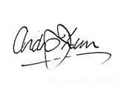 | Independent Chair/District Chair
Rev Dr Andrew Lunn

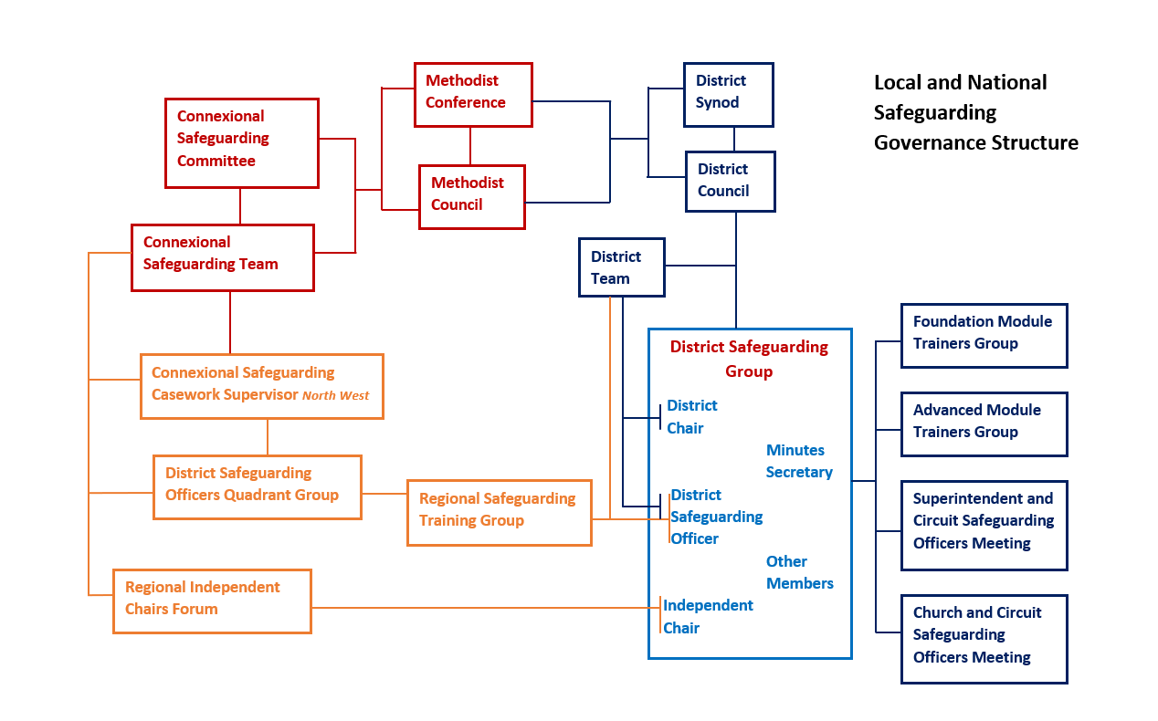
Appendix 1 National and local safeguarding governance structure

Appendix 2 Membership of Manchester and Stockport Methodist
District Safeguarding Group

Ex
-
officio
Members

Chair of
District
/
nominee

Independent
Chair

District
Safeguarding
Officer

)
SGO
(

Minutes
Secretary

Members
Experience

Safeguarding:
within or outside
of Methodist
Church

Children and
Young People

Vulnerable Adults
Minister

Pastoral Care

Circuit /Church
Salford, Sale,

Stretford &
Urmston
Altrincham

Shaw &
Royton,

Oldham &
Saddleworth,

Glossop &
Tameside.

Manchester

United
Stockport,

Bramhall &
Wythenshawe

Macclesfield,
High Peak
Partnership
,
Alderley Edge
& Knutsford

Co
-
opted
Subgroup
Members

Co
-
opted
Subgroup
Members

Members

Lay and ministerial

Across the

Circuits

Members

Lay and ministerial

Appendix 3
Role Description for: Independent Chair of the Manchester and
Stockport Methodist District Safeguarding
Group (DSG) - Volunteer Role

Accountable to | The District Council
Key Relationships | The Chair of District, the District Safeguarding Officer, Members of the District Safeguarding Group
Term of appointment | Initially for three years, with a possible extension of a further three years thereafter
Renumeration | Although no salary is paid for this role, costs and expenses will be agreed prior to appointment
Background | Safeguarding Policy, Procedures and Guidance for the Methodist Church in Britain (July 2020) demands that the Chair and the District Council provide support and oversight for Manchester and Stockport Methodist District in implementing safeguarding policies and procedures in local churches and circuits.  The District Safeguarding Group (DSG) is the group established to deliver this support and oversight and is responsible for the strategic development of safeguarding, in line with local and national requirements. It is also responsible for understanding local safeguarding need and for responding to and reviewing policy and procedural queries.  There is a minimum of five meetings per annum that the Independent Chair would be expected to attend. These are arranged before the start of connexional year (which begins in September) and which are held in the evenings.
Role Purpose | The DSG is guided by the Independent Chair, who offers independent scrutiny, acts as a critical friend, supports and encourages as appropriate, but also provides challenge where necessary.  For this reason, the Independent Chair must not hold any other role, paid or voluntary, within the District (including within any church or circuit therein) at the time of appointment, nor should they be a close relative of the District Chair, DSO, any minister or other employee of the Methodist Church.
Role Description | To provide effective leadership to the DSG, including agreeing the agenda for meetings with the District Safeguarding Officer (DSO)  To approve the minutes of meetings and ensure responsibilities for action are allocated and subsequently carried out.  To ensure the DSG discharges it role and functions in line with the terms of reference.  To work closely with the DSO and District Chair to ensure the group maintains a clear strategic oversight of safeguarding across the District in accordance with the most current version of Safeguarding Policy, Procedures and Guidance for the Methodist Church in Britain.  To ensure that appropriate quality assurance and risk management processes are established and reviewed regularly.  To ensure that the DSG considers the needs and views of survivors, children, young people and vulnerable adults in its work.  To engage in the Independent Chairs’ national and regional network meetings and the annual Safeguarding Conference  To ensure that the DSG receives and discusses information and themes from quality assurance processes, self-assessments, lessons learnt reviews, independent audits and file audits to make recommendations for improving safeguarding arrangements as needed

Person Specification for: Independent Chair of the Manchester
and Stockport Methodist District Safeguarding
Group – Volunteer Role
Qualifications, Knowledge and Experience | Essential or Desirable | How  assessed*
Relevant professional qualification or equivalent to degree level (e.g. social work, health, teaching, law, police), experience as a magistrate or of tribunal membership | E | App  Certs, Refs
Extensive experience of child and/or adult safeguarding from a professional perspective as above | E | App  Refs
Relevant up to date training in child and adult safeguarding at an advanced level, and with the ability to demonstrate transferrable knowledge across the client groups | E | App
Recent experience in evaluating the effectiveness of safeguarding services using a variety of methods, including quality assurance and risk management processes | E | App  IV
Knowledge of working with confidential materials subject to GDPR and when information should be shared | E | App  IV
Experience of negotiating through conflict and challenge to achieve a positive conclusion | E | App  IV
Required Skills, Abilities and Competencies

A confident and empowering leadership style with the ability to strategically plan, manage and chair meetings effectively. and influence people to build capacity and confidence in safeguarding practice. | E | App  IV
Able to identify examples of poor practices and ensure that necessary change is implemented. | E | App  IV
Excellent IT and recording skills. | E | App  IV
Excellent interpersonal and communication skills - written, oral and presentational. | E | App  IV
Other

In sympathy with the objectives, aims and ethos of the  Methodist Church | E | IV
Awareness of Connexional safeguarding policies and processes | D | IV
Awareness of the structure of the Methodist Church | D | IV
Awareness of safeguarding within a faith setting | D | IV
Appreciation of, and commitment to, diversity in all its forms | E | IV

* | App | Application form | IV | Interview | Ref | References | Cert | Certificate

Appendix 4

Role Description: for Deputy Chair of Manchester and Stockport District
Safeguarding Group

Responsible to | Independent Chair of the Manchester and Stockport Methodist DSG, Chair of District
Key Relationships | District Safeguarding Officer, Members of the District Safeguarding Group
Term of appointment | Initially for three years, with a possible extension at the end of time, subject to evaluation
Renumeration | Although no salary is paid for this role, costs and expenses will be agreed prior to appointment
Role Purpose | To support the work of the Manchester and Stockport Methodist DSG, including taking a key role in specific strands of activity or individual pieces of work.
Background | Safeguarding Policy, Procedures and Guidance for the Methodist  Church in Britain (July 2020) demands that the Chair and the District Council provide support and oversight for Manchester and  Stockport Methodist District in implementing safeguarding policies and procedures in local churches and circuits.  The District Safeguarding Group (DSG) is the group established to deliver this support and oversight and is responsible for the strategic development of safeguarding, in line with local and national requirements. It is also responsible for understanding local safeguarding need and for responding to and reviewing policy and procedural queries.
Role Description | To deputise for the Independent Chair both locally and nationally as required  To be the local driver for progressing DSG activity  To support and work closely with the DSO and activity leads as required  To contribute professional experience of safeguarding children, young people and/or vulnerable adults  To have worked as a member of a DSG for a minimum of 2 years  To support local engagement in the Independent Chairs’ national and regional network meetings and the annual Safeguarding  Conference either as well as, or as deputy for the Independent Chair  To update the Independent Chair on activity prior to every meeting of the DSG, and as required at other times  To support regular review of quality assurance and risk management processes  To support DSG consideration of the needs and views of survivors, children, young people and vulnerable adults in its work.  To support the provision and discussion of information and themes from quality assurance processes, self-assessments, lessons learnt reviews, independent audits and file audits and ensuing action plans.

Person Specification for: Deputy Chair of the Manchester and Stockport
Methodist District Safeguarding Group

Qualifications, Knowledge and Experience | Essential or Desirable | How  assessed*
Relevant professional experience in safeguarding e.g. social work, health, teaching, law, police, faith organisation, voluntary organisation | E | App  Refs
Relevant up to date training in safeguarding at an advanced level | E | App
Experience of quality assurance and risk management processes | D | App  IV
Knowledge of working with confidential materials subject to GDPR and information sharing | D | App  IV
Experience of having worked as a member of a DSG for a minimum of 2 years | E | App  IV
Required Skills, Abilities and Competencies
The ability to support the planning, management, and chairing of meetings effectively | D | App  IV
Very good IT and recording skills. | E | App  IV
Very good interpersonal and communication skills | E | App  IV
Other
Experience of having contributed to /having knowledge of the work of a Safeguarding Contract Monitoring and Support Group | D | App  IV
Knowledge and experience of Connexional safeguarding policies in practice | E | IV
* | App | Application form | IV | Interview | Ref | References
Appendix 5

Role Description for: Member of the Manchester and Stockport
Methodist District Safeguarding Group (DSG)

Responsible to | Independent Chair of the Manchester and Stockport Methodist DSG, Chair of District
Key Relationships | District Safeguarding Officer, Other Members of the District  Safeguarding Group, all members of Manchester and Stockport Methodist District
Term of appointment | Initially for three years, with a possible extension of a further three years
Renumeration | Although no salary is paid for this role, costs and expenses will be agreed prior to appointment
Role Purpose | To support the work of the Manchester and Stockport Methodist DSG, including taking a key role in specific strands of activity or individual pieces of work.
Background | Safeguarding Policy, Procedures and Guidance for the Methodist  Church in Britain (2July 2020) demands that the Chair and the District Council provide support and oversight for Manchester and Stockport Methodist District in implementing safeguarding policies and procedures in local churches and circuits.  The District Safeguarding Group (DSG) is the group established to deliver this support and oversight and is responsible for the strategic development of safeguarding, in line with local and national requirements. It is also responsible for understanding local safeguarding need and for responding to and reviewing policy and procedural queries.
Role Description | To contribute professional experience of safeguarding children, young people and/or vulnerable adults  To support the work of the DSG  To contribute towards progressing local safeguarding activity  To prepare for, attend and take forward actions from quarterly DSG meetings  To take the lead in specific activities/workstreams and share the results with the DSG

Person Specification for: Member of the Manchester and Stockport
Methodist District Safeguarding Group

Qualifications, Knowledge and Experience | Essential or Desirable | How  assessed*
Relevant professional experience in safeguarding e.g. social work, health, teaching, law, police, faith organisation, voluntary organisation | E | App  Refs
Relevant up to date training in child and/or adult safeguarding as a minimum at foundation level | E | App
Required Skills, Abilities and Competencies
Good IT skills. | E | App  IV
Good interpersonal and communication skills | E | App  IV
Other

An active minister/member of the Methodist Church within the Manchester and Stockport Methodist District | D | App
Is or has been a Church Safeguarding Officer and/or a Circuit Safeguarding Officer in the Methodist Church | D | App
Knowledge and experience of Connexional safeguarding policies | E | IV
Knowledge and experience of safeguarding within a faith setting | E | IV
* | App | Application form | IV | Interview | Ref | References

